EXPERIMENT 1 - 8 PUZZLE PROBLEM

AIM
To develop a Python program to solve the 8-Puzzle Problem using the Best First Search (Heuristic Search) algorithm.

OBJECTIVE
To prove that the Best First Search algorithm can efficiently find the shortest path from the initial state to the goal state using a heuristic function.

ALGORITHM
- Read the initial 8-puzzle configuration and define the goal state.
- Calculate the heuristic value (Manhattan Distance) for the current state.
- Select the state with the lowest heuristic value from the priority queue.
- Generate all valid child states by moving the blank tile and compute their heuristic values.
- Repeat the process until the goal state is reached, then display the solution path.

SAMPLE CODE
from queue import PriorityQueue

goal = [[1, 2, 3],
[4, 5, 6],
[7, 8, 0]]

moves = [(-1,0),(1,0),(0,-1),(0,1)]

def heuristic(state):
distance = 0
for i in range(3):
for j in range(3):
value = state[i][j]
if value != 0:
x = (value - 1) // 3
y = (value - 1) % 3
distance += abs(i - x) + abs(j - y)
return distance

def find_blank(state):
for i in range(3):
for j in range(3):
if state[i][j] == 0:
return i, j

def to_tuple(state):
return tuple(tuple(row) for row in state)

def solve(start):
pq = PriorityQueue()
pq.put((heuristic(start), start, []))
visited = set()

while not pq.empty():
h, state, path = pq.get()

if state == goal:
return path + [state]

key = to_tuple(state)
if key in visited:
continue
visited.add(key)

x, y = find_blank(state)

for dx, dy in moves:
nx, ny = x + dx, y + dy
if 0 <= nx < 3 and 0 <= ny < 3:
new_state = [row[:] for row in state]
new_state[x][y], new_state[nx][ny] = new_state[nx][ny], new_state[x][y]
pq.put((heuristic(new_state), new_state, path + [state]))

return None

start = [[1, 2, 3],
[4, 0, 6],
[7, 5, 8]]

solution = solve(start)

if solution:
print("Solution Steps:")
for step in solution:
for row in step:
print(row)
print()
else:
print("No Solution Found")

FLOW CHART
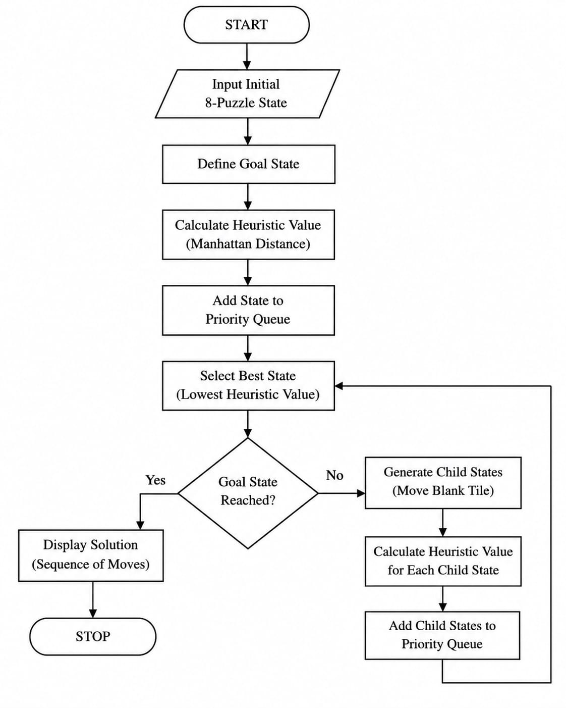

OUTPUT
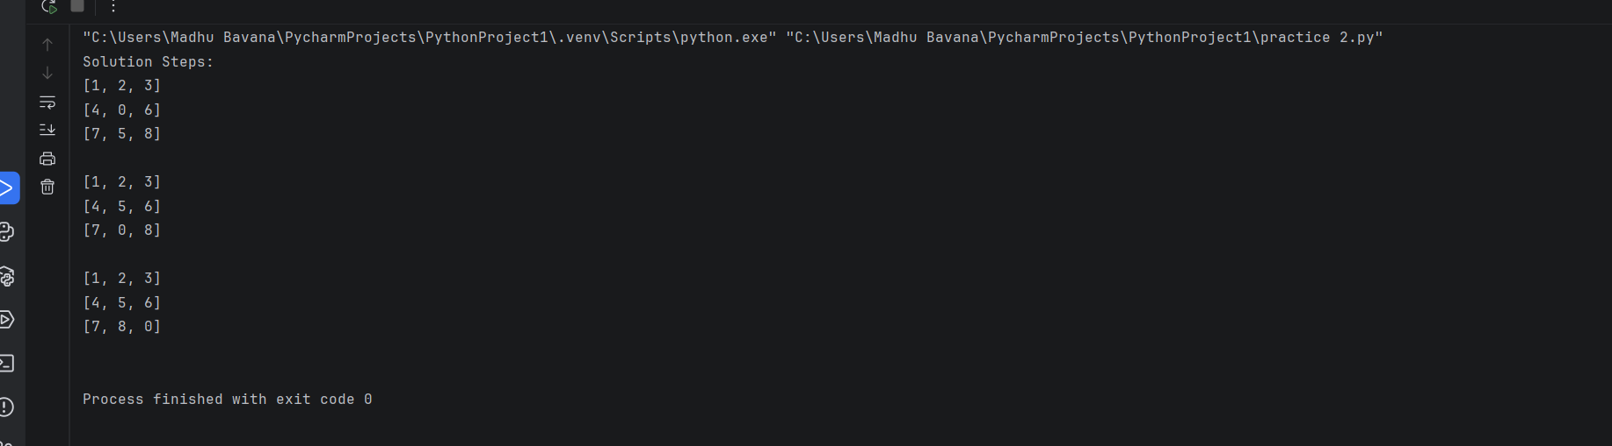

RESULT
The Python program was executed successfully. The Best First Search algorithm solved the 8-Puzzle Problem by finding the sequence of moves from the initial state to the goal state using the heuristic function, thereby reaching the solution efficiently.

